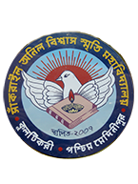
SANKRAIL ANIL BISWAS SMRITI MAHAVIDYALAYA
Affiliated to Vidyasagar University
Accredited by NAAC
AT & P.O- KULTIKRI, DIST- JHARGRAM, PIN-721135 (W.B.)

Memo No....................................... Date: 23/09/2020

Notice

This is to notify that our admission portal will reopen from 24/09/2020 to 27/09/2020 for fresh application.

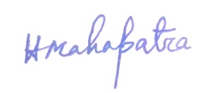
Teacher-in-Charge
